Computing Strand Stress at Various Stages

No Temporary Strands

Permanent Strand Stress
At jacking | 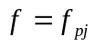
Before Transfer | 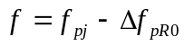
After Transfer/At Lifting | 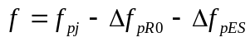
At Shipping | 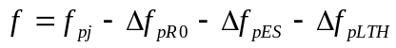  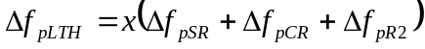 // refined method before 2005  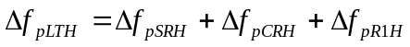 // refined method after 2005  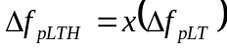 // approximate methods
After Deck Placement | 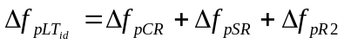 // refined before 2005 (assume all losses occur at deck placement)  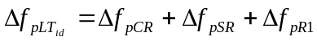 // refined after 2005  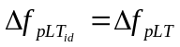 // approximate methods (assume all losses occur at deck placement)
After All Losses | 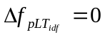 // refined before 2005  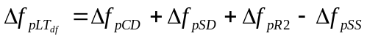 // refined after 2005  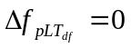// approximate methods

Pretensioned Temporary Strands

Permanent Strand Stress
At jacking
Before Transfer | 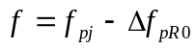
After Transfer/At Lifting
At Shipping | // refined method before 2005  // refined method after 2005  // approximate methods
Before Temporary Strand Removal | 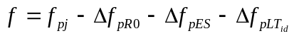  // refined before 2005 (assume all losses occur at deck placement)  // refined after 2005  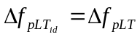 // approximate methods (assume all losses occur at deck placement)
After Temp Strand Removal | 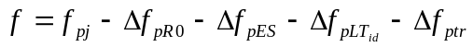
After Deck Placement
After All Losses | // refined before 2005  // refined after 2005  // approximate methods

Temporary Strand Stresses
At jacking
Before Transfer
After Transfer/At Lifting
At Shipping | // refined method before 2005  // refined method after 2005  // approximate methods
Before Temporary Strand Removal | // refined before 2005 (assume all losses occur at deck placement)  // refined after 2005  // approximate methods (assume all losses occur at deck placement)

Temporary Strands Post-Tensioned Before Lifting

Permanent Strand Stress
At jacking
Before Transfer
After Transfer
After PT/Lifting | 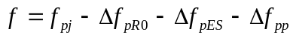
At Shipping | 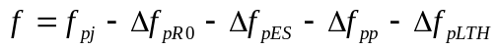  // refined method before 2005  // refined method after 2005  // approximate methods
Before Temp Strand Removal | 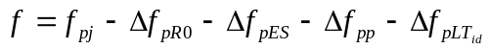  // refined before 2005 (assume all losses occur at deck placement)  // refined after 2005  // approximate methods (assume all losses occur at deck placement)
After Temp Strand Removal
After Deck Placement
After All Losses | // refined before 2005  // refined after 2005  // approximate methods

Temporary Strand Stresses
After PT Installation | 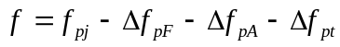
At Lifting
At Shipping | 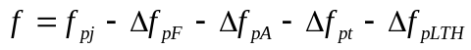  // refined method before 2005  // refined method after 2005  // approximate methods
Before Temp Strand Removal | 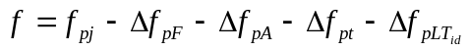  // refined before 2005 (assume all losses occur at deck placement)  // refined after 2005  // approximate methods (assume all losses occur at deck placement)

Temporary Strands Post-Tensioned After Lifting

Permanent Strand Stress
At jacking
Before Transfer
After Transfer
At Lifting
After PT Installed
At Shipping | 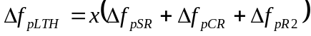 // refined method before 2005  // refined method after 2005  // approximate methods
Before Temp Strand Removal | // refined before 2005 (assume all losses occur at deck placement)  // refined after 2005  // approximate methods (assume all losses occur at deck placement)
After Temp Strand Removal
After Deck Placement
After All Losses | // refined before 2005  // refined after 2005  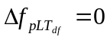// approximate methods

Temporary Strand Stresses
After PT Installed
At Shipping | // refined method before 2005  // refined method after 2005  // approximate methods
Before Temp Strand Removal | // refined before 2005 (assume all losses occur at deck placement)  // refined after 2005  // approximate methods (assume all losses occur at deck placement)

Temporary Strands Post-Tensioned Before Shipping

Permanent Strand Stress
At jacking
Before Transfer
After Transfer
At Lifting
After PT Installation | // refined method before 2005  // refined method after 2005  // approximate methods
At Shipping
Before Temp Strand Removal | // refined before 2005 (assume all losses occur at deck placement)  // refined after 2005  // approximate methods (assume all losses occur at deck placement)
After Temp Strand Removal
After Deck Placement
After All Losses | // refined before 2005  // refined after 2005  // approximate methods

Temporary Strand Stresses
After PT Installation
At Shipping
Before Temp Strand Removal

Notation
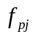 | Stress in the prestressing steel at jacking
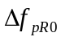 | Relaxation loss between stressing and prestress transfer
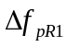 | Total long term relaxation loss (LRFD 2005 and earlier)  Relaxation loss between release and deck placement
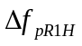 | Relaxation loss between release and shipping
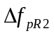 | Relaxation loss between deck placement and final
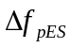 | Loss due to elastic shortening
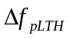 | Time dependent losses at time of shipping
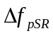 | Total shrinkage loss (LRFD 2005 and earlier)  Shrinkage loss between release and deck placement
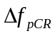 | Total creep loss (LRFD 2005 and earlier)  Creep loss between release and deck placement
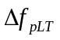 | Total time dependent loss (LRFD 2005 and earlier)
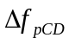 | Creep loss between deck placement and final
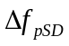 | Shrinkage loss between deck placement and final
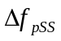 | Loss due to deck shrinkage
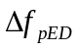 | Elastic gain due to deck placement
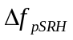 | Shrinkage loss between release and shipping
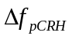 | Creep loss between release and shipping
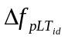 | Time dependent losses between release and deck placement
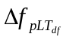 | Time dependent losses between deck placement and final
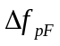 | Loss due to friction
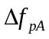 | Loss due to anchor set
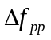 | Change in stress in permanent strands due to installation of the temporary strands
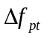 | Average change in stress in the temporary strands due to installation of subsequent temporary strands
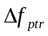 | Change in stress in permanent strands due to removal of the temporary strands

